Analytical Problem Solving
Warehouse Delivery Robot – Intelligent Agent and Search Problem

Given:
This problem considers a delivery robot operating in a 5 × 5 warehouse grid. The robot starts at cell (1,1) and must deliver a package to the destination cell (5,5). Some cells are blocked because of shelving, and the robot cannot move through these cells.
The robot can move only in four directions: Up, Down, Left, and Right. Diagonal movement is not allowed. Each movement has a uniform cost of 1.
The blocked cells are:
- (2,2)
- (2,3)
- (3,3)
- (4,2)
The problem is solved using intelligent-agent modeling, Breadth-First Search (BFS), and Depth-First Search (DFS).

Problem Representation
The warehouse can be represented using the following 5 × 5 grid.
Row / Column | 1 | 2 | 3 | 4 | 5
1 | S | Free | Free | Free | Free
2 | Free | X | X | Free | Free
3 | Free | Free | X | Free | Free
4 | Free | X | Free | Free | Free
5 | Free | Free | Free | Free | G

S= Starting Position (1,1)
G= Goal Position (5,5)
X=Blocked cell
The robot has to find a valid path from S to G without entering any blocked cell.

A) PEAS Description of the Intelligent Agent
PEAS stands for:
- P – Performance Measure
- E – Environment
- A – Actuators
- S – Sensors
PEAS is used to describe the task environment in which an intelligent agent operates.
PEAS Description
PEAS Component | Description
Performance Measure | Successfully deliver the package to cell (5,5), avoid blocked cells, minimize the number of movements, and minimize total path cost.
Environment | A 5 × 5 warehouse grid containing free cells and blocked cells caused by shelving.
Actuators | The robot's movement mechanisms that allow it to move Up, Down, Left, or Right. The robot can also perform the delivery action at the destination.
Sensors | Sensors provide the robot with its current position and information about nearby cells, obstacles, and the destination.

Environment Characteristics
The warehouse environment can also be classified according to the following properties:
Property | Classification | Explanation
Number of agents | Single-agent | Only one robot is solving the problem.
Observability | Fully observable | The warehouse layout and blocked cells are known.
Determinism | Deterministic | A movement always produces the expected result if it is legal.
Environment | Static | The blocked cells and warehouse layout do not change during the search.
State space | Discrete | The robot occupies one discrete grid cell at a time.
Actions | Four actions | Up, Down, Left, and Right.
Step cost | Uniform | Every legal movement has cost 1.

The robot's main objective is to deliver the package to the destination. Therefore, the performance measure mainly depends on whether the robot reaches (5,5) successfully and how efficiently it gets there.
The environment is fully observable and deterministic because the robot knows the grid and the locations of the blocked cells. The robot's actuators are responsible for movement, while its sensors provide information about its current location and surroundings.

B) Classification of the Intelligent Agent
The most suitable type of intelligent agent for this problem is a:
Goal-Based Agent
A goal-based agent selects actions based on a desired goal state.
In this problem, the goal is:
Reach cell (5,5) and deliver the package.
The robot must plan a sequence of movements that takes it from (1,1) to (5,5) while avoiding the blocked cells.
Comparison of Agent Types
Agent Type | Suitability | Reason
Simple Reflex Agent | Not suitable | It mainly reacts to the current percept and does not plan a complete route toward the destination.
Model-Based Agent | Possible | It can maintain an internal model of the environment, but the problem mainly requires goal-directed path planning.
Goal-Based Agent | Best suited | It selects actions with the specific objective of reaching the destination.
Utility-Based Agent | Not necessary | Utility functions are useful when several objectives or preferences need to be compared. This problem mainly has one goal with uniform movement costs.

A goal-based agent is the best choice because the robot has a clearly defined goal state, which is (5,5). The robot needs to determine a sequence of actions that will reach this state while avoiding obstacles.
For example, the robot may choose:
Down → Down → Down → Down → Right → Right → Right → Right
This sequence reaches the goal while avoiding the blocked cells.
Therefore:
The warehouse delivery robot is best modeled as a goal-based intelligent agent.

C ) Formal Search Problem
The warehouse problem can be formulated as a classical search problem using five components:
- Initial State
- Goal State
- Actions
- Transition Model
- Path Cost
Search Problem Definition
Component | Definition
Initial State | (1,1)
Goal State | (5,5)
Actions | Up, Down, Left, Right
Transition Model | A legal movement changes the robot's current cell to the adjacent free cell. Movement outside the grid or into a blocked cell is not allowed.
Path Cost | Every movement costs 1. Therefore, total path cost equals the number of movements.
Initial State
The robot initially starts at = (1,1)
Goal State
The required destination is: (5,5)

Actions
The robot has four possible actions:
A=(Up,Down,Right,Left)
However, an action is allowed only if the resulting cell:
- is inside the 5 × 5 grid, and
- is not blocked.
Transition Model
If the robot is currently at: (r,c)
then the possible new positions are:
$$\left(r , -1c\right), \left(r , +1c\right), \left(r , c-1\right), \left(r , c+1\right)$$
provided that the resulting position is valid and not blocked.
Path Cost
Each movement has a cost of 1.
Therefore:
$$\text{Path Cost}=\text{Number of Moves}$$
For example, if the robot makes 8 movements:
$$\text{Cost}=8×1=8$$

D) Breadth-First Search (BFS)
BFS Concept
Breadth-First Search (BFS) explores the search space level by level. It first explores all states at depth 1, then all states at depth 2, then depth 3, and so on.
BFS uses a Queue, which follows the FIFO (First-In, First-Out) principle.
Since every movement in this problem has the same cost of 1, BFS is guaranteed to find the shortest path.
For the following expansion, the movement order is taken as:
Up → Down → Left → Right
Already visited cells are not inserted into the queue again.

BFS Step-by-Step Expansion
Step | Expanded Node | New Nodes Added | Queue / Frontier After Expansion
1 | (1,1) | (2,1), (1,2) | (2,1), (1,2)
2 | (2,1) | (3,1) | (1,2), (3,1)
3 | (1,2) | (1,3) | (3,1), (1,3)
4 | (3,1) | (4,1), (3,2) | (1,3), (4,1), (3,2)
5 | (1,3) | (1,4) | (4,1), (3,2), (1,4)
6 | (4,1) | (5,1) | (3,2), (1,4), (5,1)
7 | (3,2) | — | (1,4), (5,1)
8 | (1,4) | (2,4), (1,5) | (5,1), (2,4), (1,5)
9 | (5,1) | (5,2) | (2,4), (1,5), (5,2)
10 | (2,4) | (3,4), (2,5) | (1,5), (5,2), (3,4), (2,5)
11 | (1,5) | — | (5,2), (3,4), (2,5)
12 | (5,2) | (5,3) | (3,4), (2,5), (5,3)
13 | (3,4) | (4,4), (3,5) | (2,5), (5,3), (4,4), (3,5)
14 | (2,5) | — | (5,3), (4,4), (3,5)
15 | (5,3) | (4,3), (5,4) | (4,4), (3,5), (4,3), (5,4)
16 | (4,4) | (4,5) | (3,5), (4,3), (5,4), (4,5)
17 | (3,5) | — | (4,3), (5,4), (4,5)
18 | (4,3) | — | (5,4), (4,5)
19 | (5,4) | (5,5) | (4,5), (5,5)
20 | (4,5) | — | (5,5)
21 | (5,5) | Goal reached | —
Path Representation
(1,1)
↓
(2,1)
↓
(3,1)
↓
(4,1)
↓
(5,1) → (5,2) → (5,3) → (5,4) → (5,5)
BFS Cost
There are 8 movements.
BFS Cost is 8

BFS Result
BFS successfully reaches the destination with a minimum cost of 8. Because all movements have equal cost, this is the optimal path.

E)Depth-First Search (DFS)
DFS Concept
Depth-First Search (DFS) explores one branch as deeply as possible before backtracking and exploring another branch.
DFS uses a Stack, which follows the LIFO (Last-In, First-Out) principle.
Unlike BFS, DFS does not guarantee the shortest path.
For this demonstration, the neighboring cells are considered in the order:
Up → Down → Right → Left
Since DFS uses a stack, the last inserted valid node is explored first.

DFS Step-by-Step Expansion
Step | Expanded Node | New Nodes Added | Stack After Expansion
1 | (1,1) | (2,1), (1,2) | (1,2), (2,1)
2 | (1,2) | (1,3) | (1,3), (2,1)
3 | (1,3) | (1,4) | (1,4), (2,1)
4 | (1,4) | (2,4), (1,5) | (1,5), (2,4), (2,1)
5 | (1,5) | (2,5) | (2,5), (2,4), (2,1)
6 | (2,5) | (3,5) | (3,5), (2,4), (2,1)
7 | (3,5) | (3,4), (4,5) | (3,4), (4,5), (2,4), (2,1)
8 | (3,4) | (4,4) | (4,4), (4,5), (2,4), (2,1)
9 | (4,4) | (5,4), (4,3) | (4,3), (5,4), (4,5), (2,4), (2,1)
10 | (4,3) | (5,3) | (5,3), (5,4), (4,5), (2,4), (2,1)
11 | (5,3) | (5,2) | (5,2), (5,4), (4,5), (2,4), (2,1)
12 | (5,2) | (5,1) | (5,1), (5,4), (4,5), (2,4), (2,1)
13 | (5,1) | (4,1) | (4,1), (5,4), (4,5), (2,4), (2,1)
14 | (4,1) | (3,1) | (3,1), (5,4), (4,5), (2,4), (2,1)
15 | (3,1) | (3,2) | (3,2), (5,4), (4,5), (2,4), (2,1)
16 | (3,2) | — | (5,4), (4,5), (2,4), (2,1)
17 | (5,4) | (5,5) | (5,5), (4,5), (2,4), (2,1)
18 | (5,5) | Goal reached | —

Path Representation
(1,1) → (1,2) → (1,3) → (1,4) → (1,5)
↓
(2,5)
↓
(3,5)
↓
(3,4)
↓
(4,4)
↓
(5,4) → (5,5)
DFS Cost
The path contains 10 movements.
$$\text{Cost}=10×1$$
DFS Cost= 10
DFS Result
DFS successfully reaches the goal, but the path found is longer than the path found by BFS.
Therefore, for this particular search order:
DFS is greater than BFS
DFS's exact path can change depending on the order in which neighboring cells are explored. However, DFS in general does not guarantee an optimal path.

F) Comparison of BFS and DFS
BFS and DFS are both uninformed search algorithms, but they behave differently.
Comparison Table
Feature | BFS | DFS
Data Structure | Queue | Stack
Principle | Explores level by level | Explores one branch deeply
Complete | Yes, for a finite branching problem | Yes for this finite grid when visited states are maintained
Optimal | Yes, when all step costs are equal | No
Time Complexity | $$O\left(b^{d}\right)$$ | $$O\left(b^{m}\right)$$
Space Complexity | $$O\left(b^{d}\right)$$ | $$O\left(bm\right)$$
Path obtained here | 8 moves | 10 moves
Path Cost | 8 | 10
Memory Requirement | Higher | Lower
Main Advantage | Finds shortest path | Uses less memory
Main Disadvantage | Requires more memory | May find a longer path
Suitability here | Highly suitable | Less suitable
Where:
- b = branching factor
- d = depth of the shallowest solution
- m = maximum depth of the search tree

BFS is Better :
The warehouse robot has a uniform movement cost:
$$\text{Cost of every movement}=1$$
Therefore, minimizing the total cost is equivalent to minimizing the number of movements.
BFS explores the search space level by level. It therefore reaches the goal at the shallowest possible depth.
In this problem:
BFS Cost = 8
while:
DFS Cost = 10
Thus, BFS produces a more efficient route.
DFS could potentially find a solution faster in some search spaces and uses less memory, but it may follow an unnecessarily long path before reaching the destination.
Final Conclusion
For the warehouse delivery robot, BFS is more suitable than DFS because:
- The movement costs are uniform.
- The objective is to find a minimum-cost path.
- BFS is complete.
- BFS guarantees the shortest path under uniform step costs.
- BFS finds an 8-move path in this problem.
- DFS finds a 10-move path with the chosen search order.
Therefore: $\text{BFS is the preferred search algorithm for this warehouse problem}$

Program:
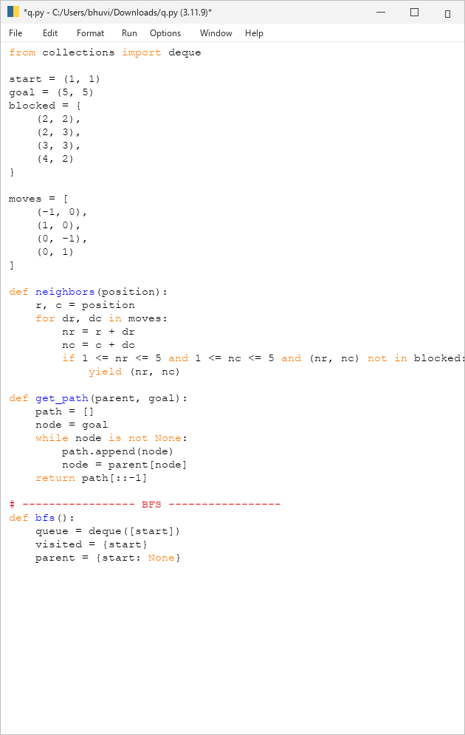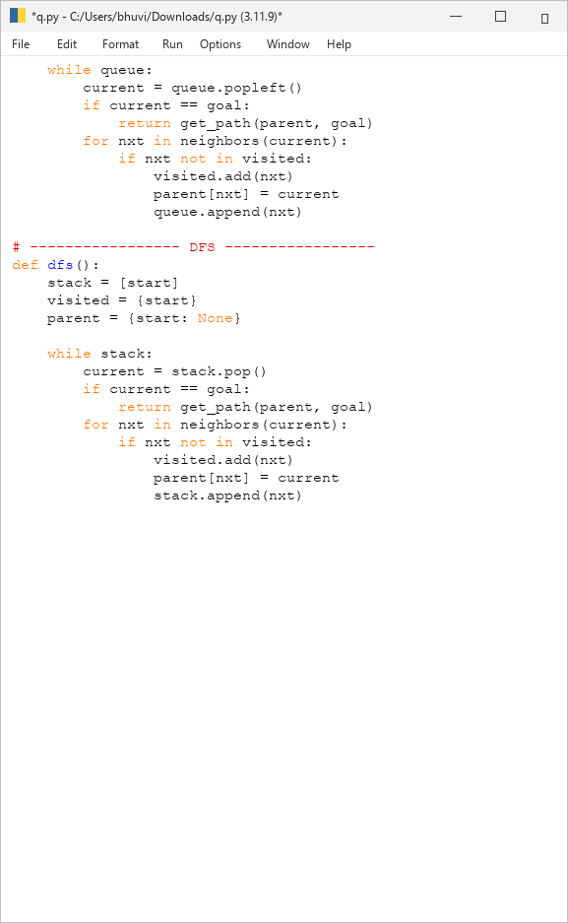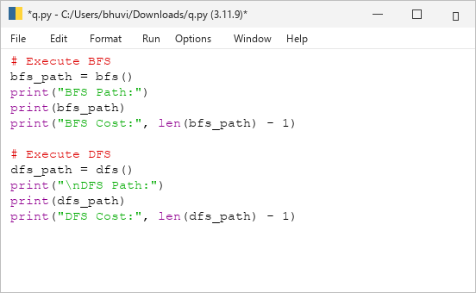

Output:
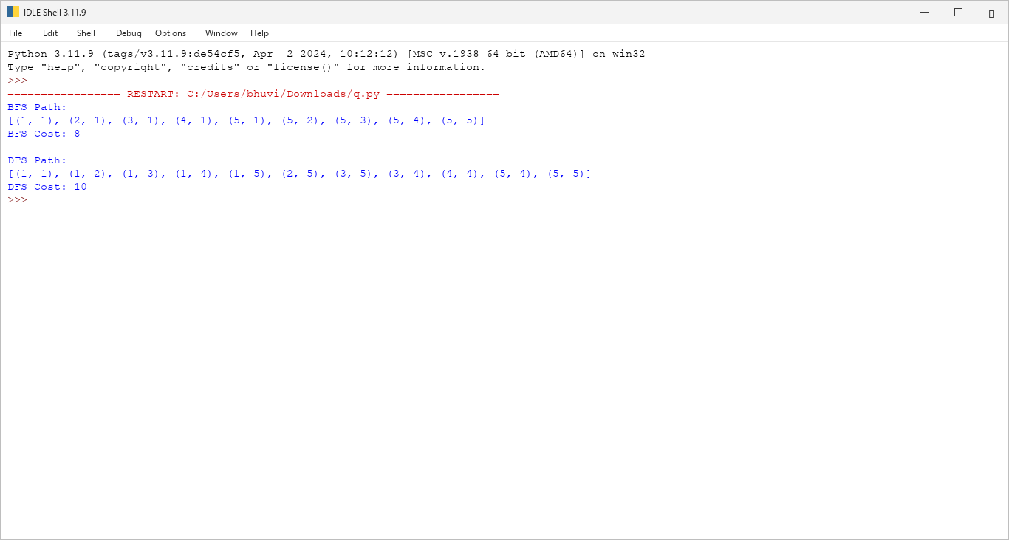

Final Results Table
Algorithm | Path Length | Total Cost | Optimal?
BFS | 8 moves | 8 | Yes
DFS | 10 moves | 10 | No
Hence, BFS is the most suitable algorithm for this warehouse delivery problem because it guarantees the shortest path when all movements have equal cost.

Conclusion
The warehouse delivery problem was successfully modeled as an intelligent-agent and search problem. The robot was represented using the PEAS framework, and a goal-based agent was identified as the most suitable agent type.
The search problem was formally defined using the initial state, goal state, actions, transition model, and path cost. BFS and DFS were then applied to the warehouse grid.

